* Abstract
  + Objective
    - Our goal was to create an automated latte art maker that can complete 3 different designs with a cup of espresso and a cup of steamed milk
  + Motivation
    - Our motivation to create this machine was inspired by our initial group meeting at a local coffee shop and our desire to combine our software and hardware skills with a creative project
* Introduction
  + Goals vs outcome
    - Goals
      * Automated machine that can complete 3 latte art designs
      * Incorporate knowledge of Python, Raspberry PI, and motor control into our project
    - Deliverables
      * 2 distinct latte art designs
      * Efficient and sturdy system
      * GUI for customer orders
* Hardware Implementation
  + Final hardware design

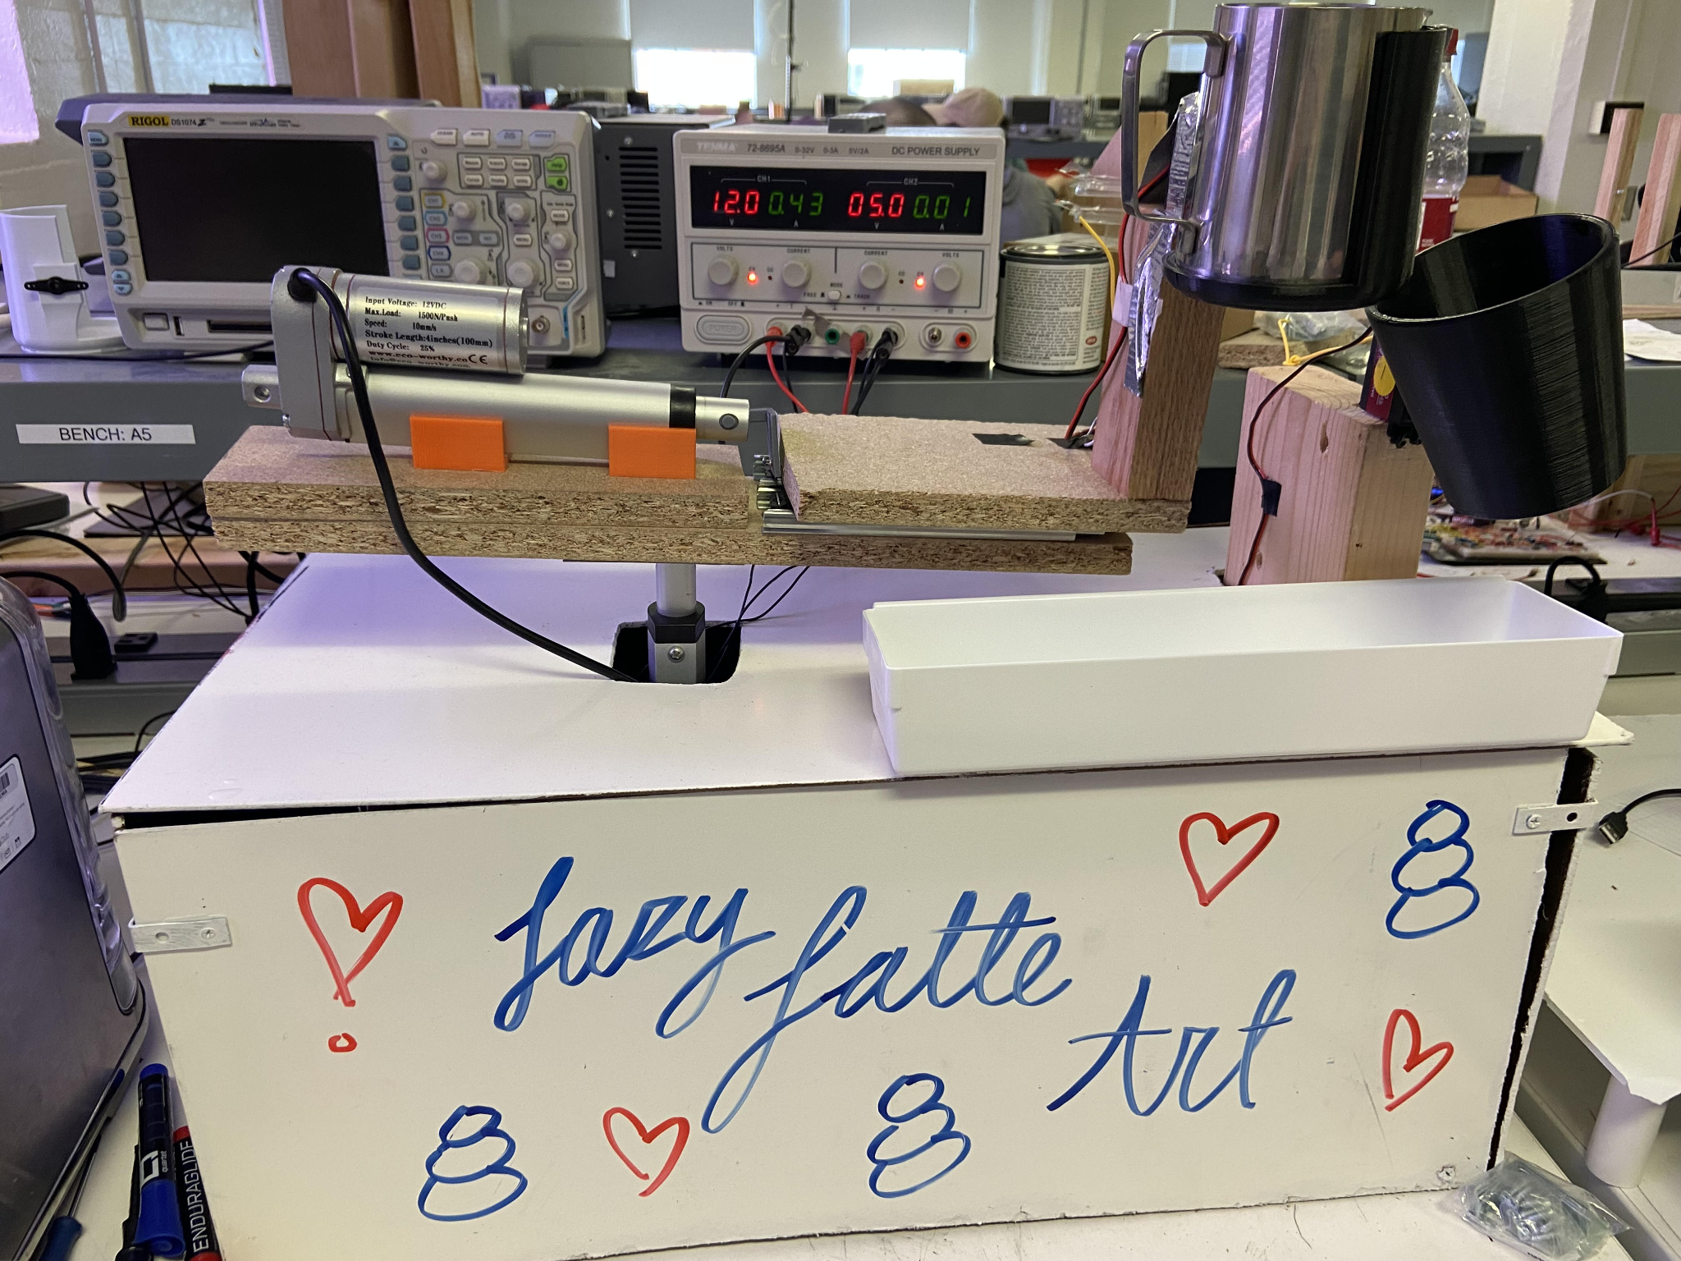

* + Hardware block diagram

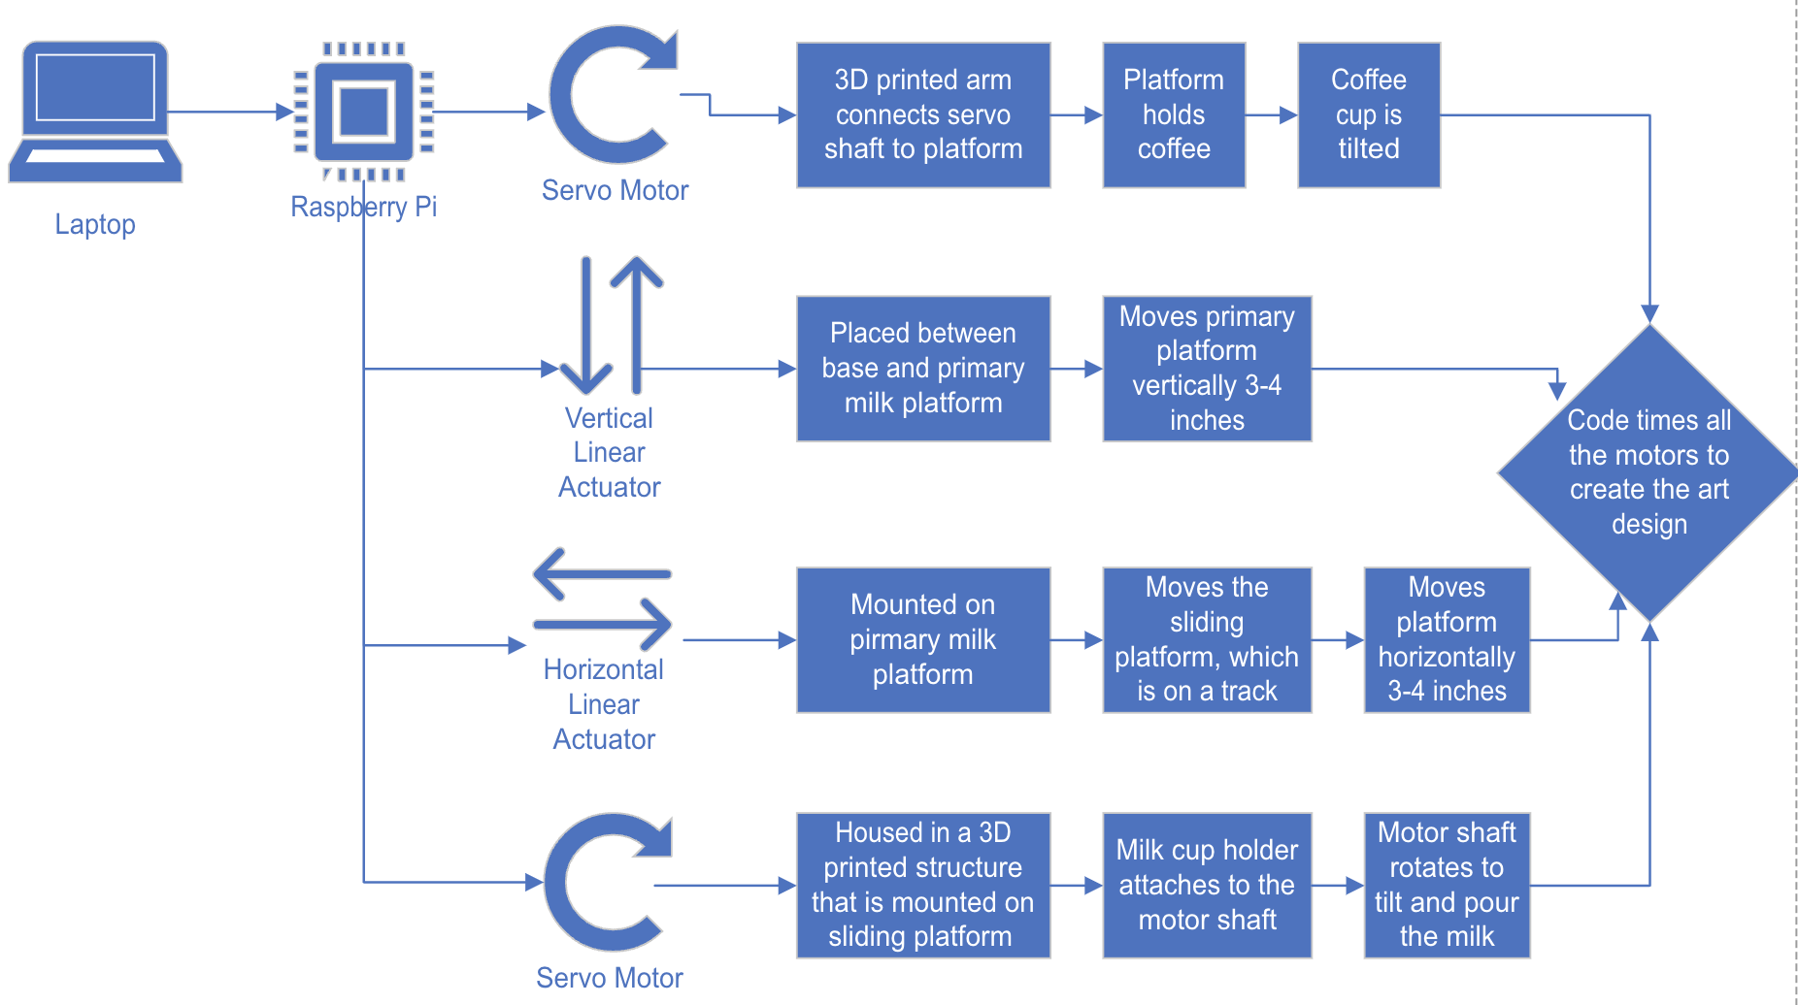

* + Drawn out design concept

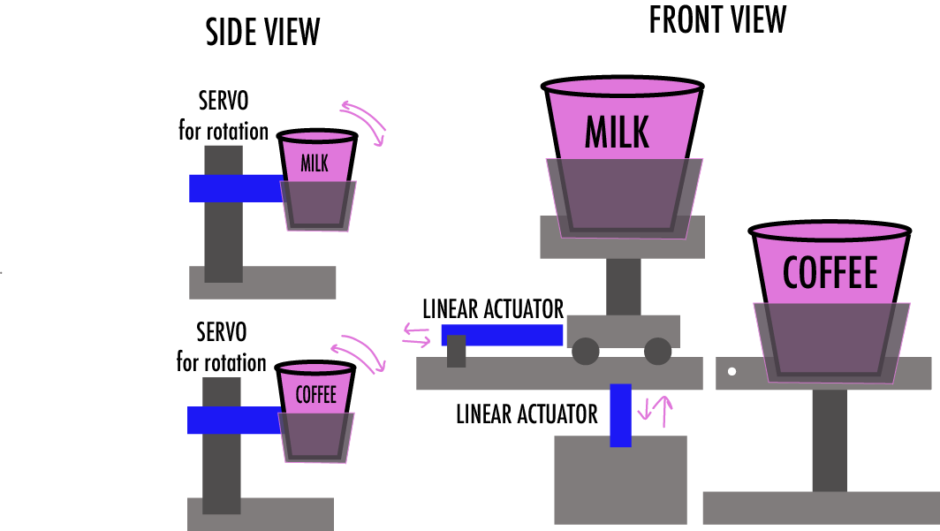

* + **Could include images of the 3d printed parts?**
* Software Implementation
  + GUI Flowchart

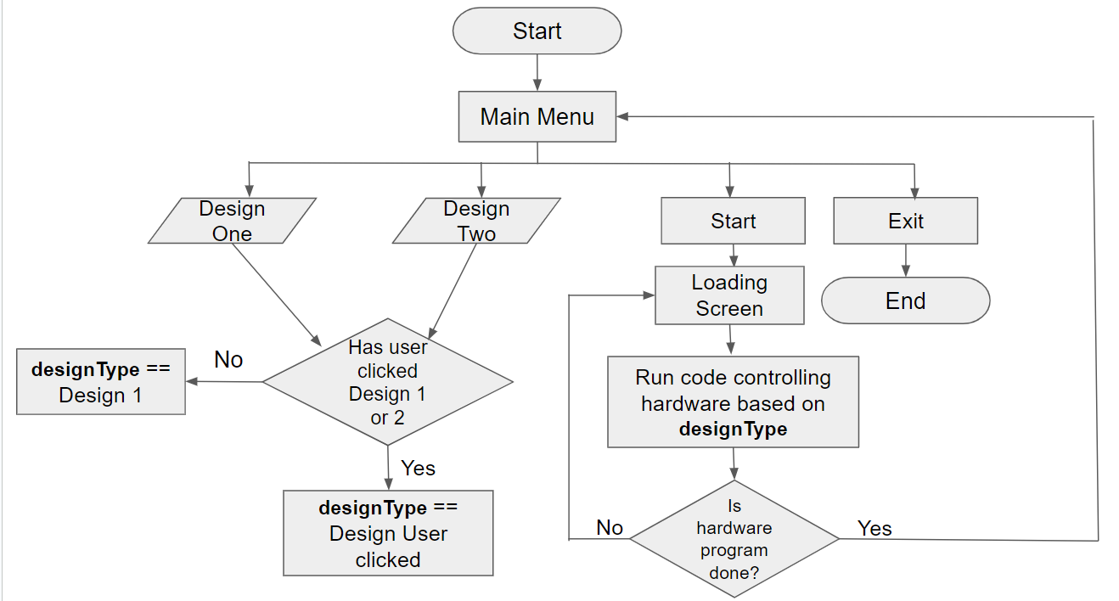

* + Actuator Flowchart

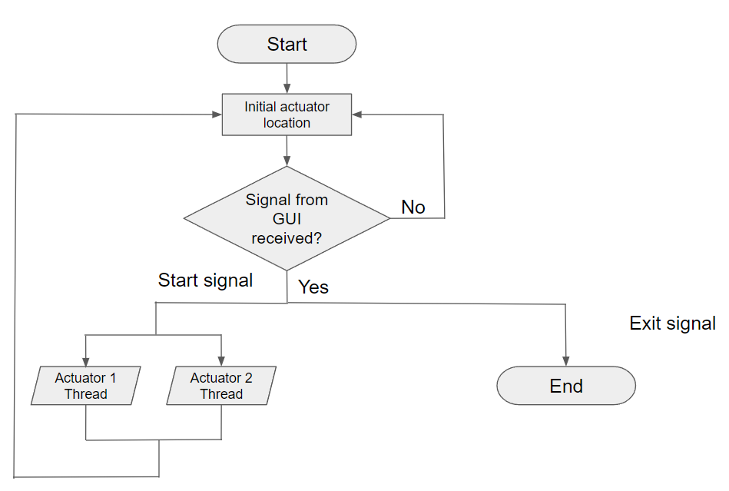

* + Servos Flowchart

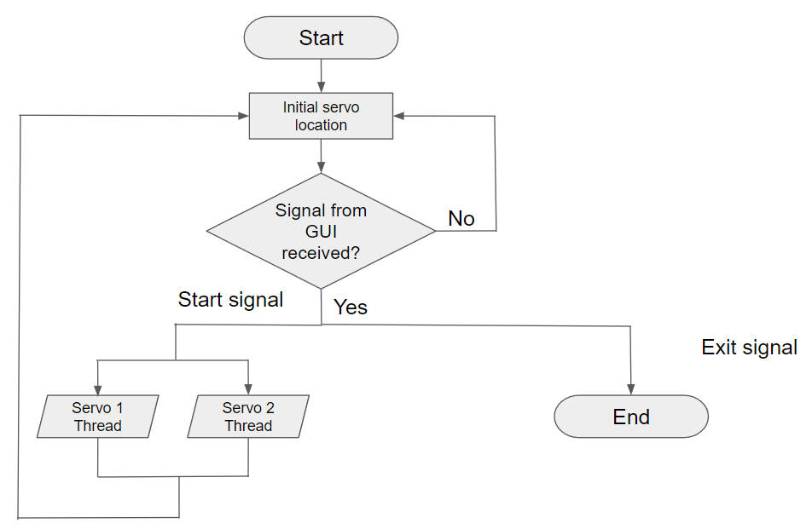

* + Software requirements
    - Rotation of the servos can be inputted as an angle
    - Milk servo ranges from 0 to 135 and coffee servo ranges from 0 to 45 degrees
    - Movement of actuators can be inputted as distances
    - Vertical actuator can go up to 4 inches and horizontal actuator can go out ot 3 inches
    - All the actuators and servos run simultaneously
    - Each latte has its own class implementing the movement functions
  + **Could add images of the two functions**
* Results
  + Progression of heart

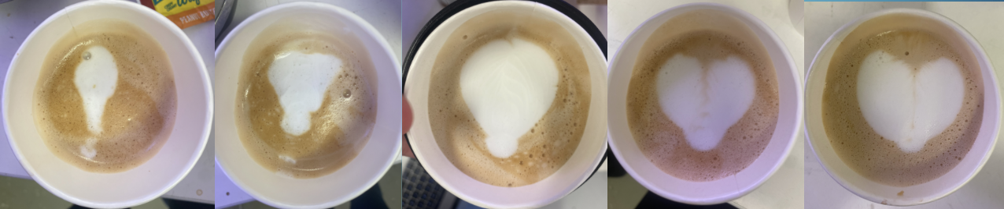

* + Progression of snowman

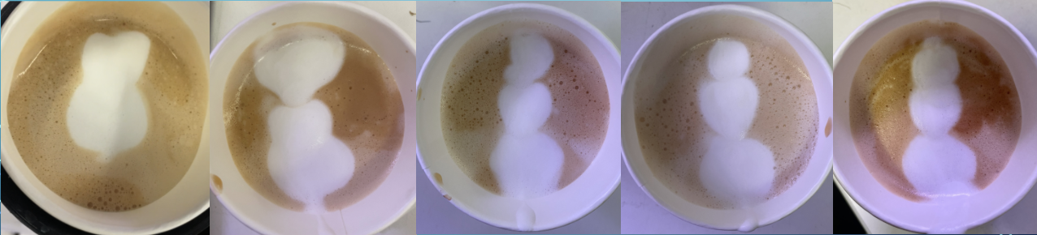

* Conclusions
* References
* Acknowledgements